AWARD

This is to certify that

<insert name here>

has completed the
CROSSING of GREENLAND
on SKIS

Dated: <insert date here>

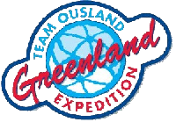

Certificate-Award Instructions

The Certificate is a simple MS Word document that can be edited in any word processing program.

Put your name in the <insert name> section. The date can also be changed as needed. Our group finished the crossing on May 29, 2015. Simply insert that date that you finished the crossing in the <insert date here> section.

When done editing, print the Certificate on any color printer. The original formatting was done for printing on 8.5” x 11” glossy photo paper. The content within the blue border measures 8” x 10” (a commonly available standard mat opening) and can be framed using off the shelf framing materials suitable to your taste.

Congratulations on completing the Crossing of Greenland!

